VCovid-19 Protocol & Cancellation Policy
S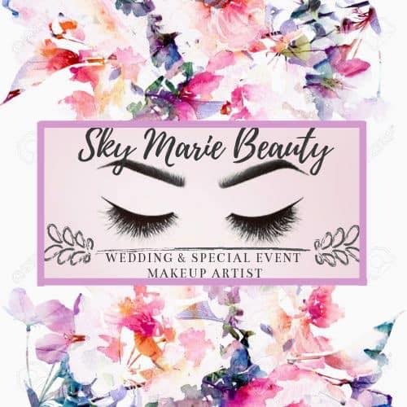
To all my clients,

Due to all of the health and safety concerns with Covid-19, I have some new protocols to instill for appointments.
The new protocols are as follows:
- Bring only your car keys, phone, and payment. No purses or bags. If you are a part of a large wedding party and your personal belongings are in the room, that is fine, just please keep it away from the makeup application station.
- Facial coverings with ear loops must be worn at all times unless you're getting your makeup done.
- Please still bring a facial covering to waiting to get your makeup done. (This would be for large events such as weddings.)
- For appointments where the artist comes to you, please refrain from touching any of the products that the artist brings. This includes not allowing others to touch the products as well. All products and brushes will be sanitized in-between applications with a 2-1-part solution made up of 99% alcohol & water.
- For appointments where the artist comes to you, please make sure there is a sink/bathroom available for handwashing. If you are symptomatic or have been around anyone who is or has been in the last 14 days you must reschedule. A cancellation fee will only be charged if you scheduled regardless of knowing you answer yes to either of those scenarios.
- Every client that is receiving makeup must fill out this Covid-19 screening form before receiving application.
- If your appointment needs to be cancelled or rescheduled due a Covid-19 related event such as a shutdown or issue, there will be no cancellation fee. For Bridal clients, the $50 booking fee can be used to hold a retainer for a later date, or it will be refunded to you with no hassle. I understand this circumstance is not your fault!
- Please respect others & be honest
Form: https://form.jotform.com/201606652021139

The makeup artist & her assistant will be wearing clean cloth masks while doing makeup and washing hands in between every single client. If you have any questions or concerns please let us know before hand so special requests can be accommodated.

Please be kind to others during this time. We will get through this. Makeup is such a vulnerable thing; we have to be in close contact with each other for it to work. I believe with all of these protocols in place, we can do it safely! Stay positive!

Thank you for understanding!

Sky Lepley
Sky Marie Beauty
Lead Makeup Artist/ Owner

